Business Explanation

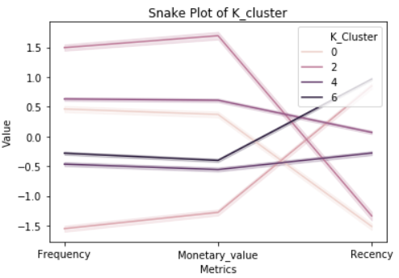

Looking at the plot above we can see that:

1. The cluster 0 have customers with average frequency of buying and average money spent and bought a while back (not recently).
2. Cluster 6 has average frequency of buying and average money spent and bought quite recently.
3. Cluster 4 has medium to high frequency and medium to high money spent and average recently shopped.